**Report**

**Loyiha Haqida:**

Ushbu loyihaning maqsadi, kredit arizalarining tasdiqlanishi yoki rad etilishi haqida predict qilish. Bu ML ni Classification modeliga tushadi, Target variablimiz kreditning tasdiqlanish holatini yani : tasdiqlangan (1) yoki rad etilgan (0).

**Maqsad**

1. Kredit arizalarining tasdiqlanish holatini predict qilish uchun MLNI o'rganish modelini yaratish.
2. Modelning samaradorligini baholash uchun Classification modellar ko'rildi: Ular>>> LogisticRegression, RandomForest, Decision Tree, KNN, SVM, XGBClassifier

**Dataset Xusiyatlari Haqida Umumiy Malumot**

**Features/ xususiyatlari**:

* Yoshi
* Daromad
* Kredit balli
* Kredit miqdori
* Ish faoliyati holati
* Ta'lim darajasi
* Oilaviy holati
* Bog'langan kishilar soni
* Oldingi kredit tarixi

**Target Variable:**

* **Kredit tasdiqlanishi holati (0 = Rad etilgan, 1 = Tasdiqlangan**

**Malumotlar Tahlili:**

Bizda null qiymatlar yoq ekan, Categoricalni Numerixcalga otkazib oldik va Label encoding yordamida ishladik, standart scalingdan foydalandik va feature ID ni predictga tasiri yoqligi uchun tashlab yubordik.

**Ishlatilgan Kutubxonalar Royxati**

| **Library** |
| --- |
| pandas |
| numpy |
| matplotlib.pyplot |
| seaborn |
| sklearn.model_selection.train_test_split |
| sklearn.ensemble.RandomForestClassifier |
| sklearn.metrics |
| joblib |
| sklearn.preprocessing.OneHotEncoder |
| sklearn.preprocessing.LabelEncoder |
| sklearn.preprocessing.PowerTransformer |
| sklearn.preprocessing.StandardScaler |
| sklearn.compose.ColumnTransformer |
| imblearn.pipeline.Pipeline |
| imblearn.over_sampling.SMOTE |
| sklearn.tree.DecisionTreeClassifier |
| sklearn.svm.SVC |
| sklearn.neighbors.KNeighborsClassifier |
| xgboost.XGBClassifier |

**Performance Metrics Table for Each Classifier:**

| **Model** | **Accuracy** | **Precision** | **Recall** | **F1 Score** |
| --- | --- | --- | --- | --- |
| **Random Forest** | 98.36% | 98.38% | 98.36% | 98.36% |
| **Decision Tree** | 92.27% | 92.25% | 92.27% | 92.24% |
| **SVM** | 94.85% | 94.84% | 94.85% | 94.83% |
| **KNN** | 90.87% | 90.83% | 90.87% | 90.84% |
| **XGBoost** | 98.01% | 98.01% | 98.01% | 98.00% |

**Comparison of Classifier Performance Metrics:**

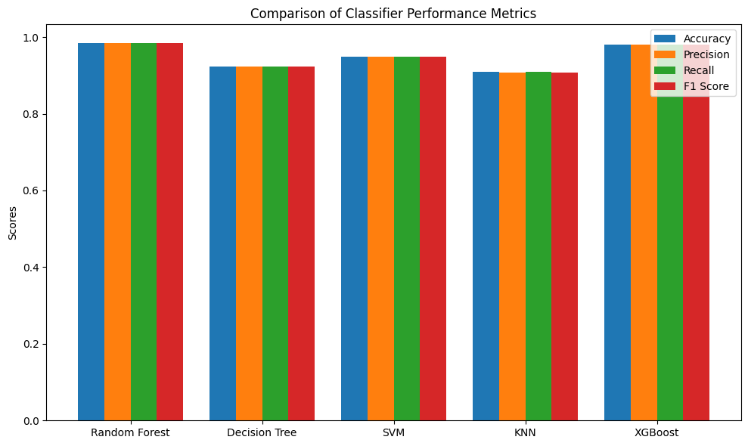

**Xulosa va Natijalar**

* Random Forest modeli kreditni tasdiqlashni predict qilishda eng yaxshi ishladi.
* KNN MODEL bizda eng yomon natijani korsatdi .

